**Q1a)**

Plot 1

|  |  |
| --- | --- |
| divorced | 9.577 |
| married | 11.096 |
| others | 8.875 |
| single | 10.035 |

Plot 2

|  |  |
| --- | --- |
| Citizen | 9.898 |
| Non-resident | 10.813 |
| PR | 12.297 |

**Q1b)**

#plot 1

df_mean1 = df.groupby(['Marital']).mean()  
df_mean1 = df_mean1.reset_index()  
df_mean1.head()  
#plot 1

fig = plt.figure(figsize = (10, 5))

# creating the bar plot

plt.bar(df_mean1['Marital'], df_mean1['Absence'], color ='maroon',

width = 0.4)

plt.xlabel("Marital Status")

plt.ylabel("Absentees")

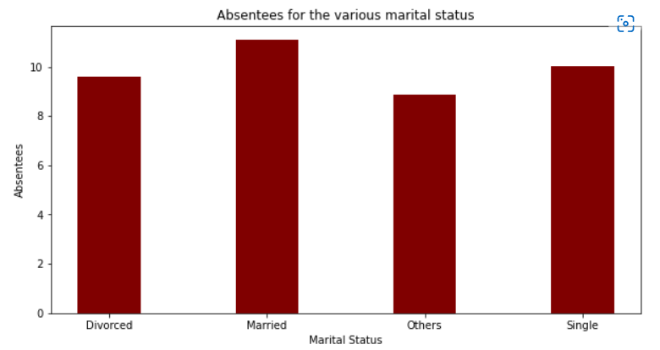plt.title("Absentees for the various marital status")  
plt.show()

#Plot 2

# creating the bar plot

plt.bar(df_mean2['Citizenship'], df_mean2['Absence'], color ='maroon',

width = 0.4)

plt.xlabel("Courses offered")

plt.ylabel("No. of students enrolled")

plt.title("Students enrolled in different courses")

plt.show()

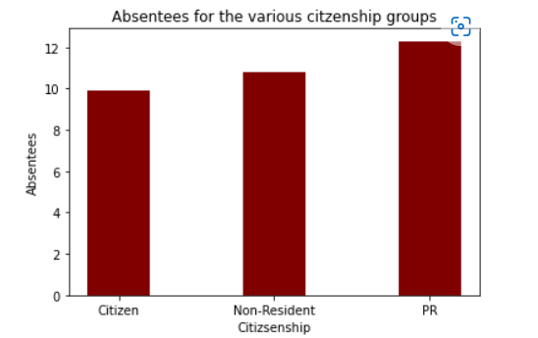

**Q1c)**

df['LeftDate'] = df['LeftDate'].fillna('1/5/2022')

df['LeftDate'] = pd.to_datetime(df['LeftDate'], format='%m/%d/%Y')

df['JoinDate'] = df['JoinDate'].fillna('1/5/2022')

df['JoinDate'] = pd.to_datetime(df['JoinDate'], format='%m/%d/%Y')

df['duration in days'] = (df['LeftDate'] - df['JoinDate']).dt.days

df['duration in days']

df['duration in years'] = df['duration in days']/365

df['duration in years']

max_service = round(max(df['duration in years']), 1)

min_service = round(min(df['duration in years']), 1)

print(“The maximum service is” + str(max_service) + “ years while the minumum service is “ + str(min_service) + “ years.”)

**Q1d)**

loop = True

while loop:

user_input = input("Please input the full name of the person: ")

loop2 = 'not_here'

for i in df['Staff']:

if user_input == i:

print("Yes, this person is part of the organisation")

loop2 = 'its_here'

pass

if loop2 == 'not_here':

print("No, this person is not part of the organisation")